LONDON EDUCATION BUILDING  
 **BIM EXECUTION PLAN**

GENARAL CONTRACTOR  
 **LONDON CONSTRUCTION**

TABLE OF CONTENTS

SECTION A: GENERAL DESCRIPTION OF BIM PROJECT EXECUTION PLAN

SECTION B: PROJECT INFORMATION

SECTION C: PROJECT GOALS / BIM USES

SECTION D: ROLES AND RESPONSIBILITIES

SECTION E: BIM PROCESS DESIGN

SECTION F: BIM INFORMATION EXCHANGE

SECTION G: MODEL STRUCTURE

SECTION H: COMMON DATE ENVIRONMENT

SECTION I: DATA SEGREGATION/FEDERATION

SECTION J: COLABORATION PROCEDURES

SECTION K: QUALITY CONTROL

SECTION L: TECHNICAL INFRASTRUCTURE REQUIREMENT

SECTION M: PROJECT DELIVERABLES

SECTION N: DELIVERY STRATEGY / CONTRACT

**SECTION A: GENERAL DESCRIPTION OF BIM PROJECT IMPLEMENTATION PLAN**

In order to successfully implement Building Information Modeling (BIM) in the project, this detailed

BIM PROJECT EXECUTION PLAN has been prepared.

The BIM PROJECT IEXECUTION PLAN includes the BIM uses envisaged for the project and

processes.

These plans are described in the "Pennsylvania State University - BIM Project Execution Planning Guide V2.0"template, and as described in the document, it was prepared in the early stages of the project.

It should be prepared and will be updated during the project in order to maintain its effectiveness.

BIM EXECUTION PLAN of all relevant units that will work within BIM processes within the project

document and use the latest revision of the document.

BIM EXECUTION PLAN is prepared for the design, construction and commissioning processes of the project and will be used in all of these processes.

|  |
| --- |
| **SECTION B: PROJECT INFORMATION** |

[LONDON EDUCATION CENTER] [01.11.2022]

**1. PROJECT OWNER :** London Construction **2. PROJECT NAME :**  London Education Center **3. PROJECT LOCATION AND ADDRESS:** London, United Kingdom **4. CONTRACT TYPE / DELIVERY METHOD:**  **5. BRIEF PROJECT DESCRIPTION:** Two storey educational center with 1680 m² construction area designed on a single plot.  
**6. ADDITIONAL PROJECT INFORMATION:** Since revisions are foreseen during the sedign phase, it will be modeled on a floor basis.  
**7. PROJECT NUMBERS:** 2508

**8. PROJECT SCHEDULE / PHASES / MILESTONES:**

|  |  |  |  |
| --- | --- | --- | --- |
| **PROJECT PHASE MILESTONE** | **ESTIMATED START DATE** | **ESTIMATED COMPLETION DATE** | **PROJECT STAKEHOLDERS INVOLVED** |
| PRELIMINARY PLANNING |  |  |  |
| DESIGN DOCUMENTS | 01.11.2022 | 07.12.2022 |  |
| CONSTRUCTION DOCUMENTS |  |  |  |
| CONSTRUCTION |  |  |  |

**SECTION B: PROJECT INFORMATION**

SECTION C: PROJECT GOALS / BIM USES

**Key Project Contacts Contacts TION B: PROJECT INFORMATION**

**SECTION B: PROJECT INFORMATION**

|  |  |  |  |  |  |
| --- | --- | --- | --- | --- | --- |
| **Role** | **Organization** | **Contact Name** | **Location** | **E-Mail** | **Phone** |
| Project Manager | Building modelling | Kamer ÖZKAN | ISTANBUL | kamerozkan17@gmail.com | +90 532 737 65 78 |
| Const. Manager | Building modelling | Derya ÇOBAN | TANZANIA | deryacoban111@gmail.com | +90 541 268 52 90 |
| BIM Manager | Building modelling | Yasemen ŞALDIRAK | ISTANBUL | yasemenduman92@gmail.com | +90 507 779 23 51 |
| Structural Manager | Building modelling | Alper Güler | ISTANBUL | alper-guler@windowslive.com | +90 538 559 90 22 |

1. As a way to enhance the overall efficiency of the Millennium Science Complex, several design alternatives have been selected for each discipline and Building Stimulus as a group. The design alternatives will have a large impact on many facets of the building associated with the construction and implementation. With respect to redesigning the building envelope to accommodate as a whole, each BIM goal identified for this Project Execution Plan is influenced. These alternative systems will rely heavily on the use of BIM for 3D coordination, simplifying cost estimation, and 4D modeling. Implementing BIM will allow Building Stimulus to locate design errors, serve as an initial model for material take offs, and allow for the generation of an accurate 4D model. In terms of alternative energy sources all BIM goals will be influenced except for Improve On-Site Coordination and Efficiency.
2. **Major BIM Goals / Objectives:**

|  |  |  |
| --- | --- | --- |
| **PRIORITY**  **(HIGH/ MED/ LOW)** | **GOAL DESCRIPTION** | **POTENTIAL BIM USES** |
| H | Increase Effectiveness of Design – Increase efficiency of structural system, architectural system | Design Authoring, Design Reviews, 3D Coordination, Engineering Analysis, Existing Conditions Modeling |
| H | Interdisciplinary Design Coordination – Effectively implement BIM through open communication and periodical design reviews | Design Reviews, 3D Coordination |
|  |  |  |
|  |  |  |

1. **BIM USES:**

|  |  |  |  |  |  |  |  |
| --- | --- | --- | --- | --- | --- | --- | --- |
|  | **PLAN** | **X** | **DESIGN** |  | **CONSTRUCT** |  | **OPERATE** |
|  | **PROGRAMMING** | **X** | **DESIGN AUTHORING** |  | **SITE UTILIZATION PLANNING** |  | **BUILDING MAINTENANCE SCHEDULING** |
|  | **SITE ANALYSIS** | **X** | **DESIGN REVIEWS** |  | **CONSTRUCTION SYSTEM DESIGN** |  | **BUILDING SYSTEM ANALYSIS** |
|  |  | **X** | **3D COORDINATION** |  | **3D COORDINATION** |  | **ASSET MANAGEMENT** |
|  |  | **X** | **STRUCTURAL ANALYSIS** |  | **DIGITAL FABRICATION** |  | **SPACE MANAGEMENT / TRACKING** |
|  |  |  | **LIGHTING ANALYSIS** |  | **3D CONTROL AND PLANNING** |  | **DISASTER PLANNING** |
|  |  |  | **ENERGY ANALYSIS** |  | **RECORD MODELING** |  | **RECORD MODELING** |
|  |  |  | **MECHANICAL ANALYSIS** |  |  |  |  |
|  |  |  | **OTHER ENG. ANALYSIS** |  |  |  |  |
|  |  |  | **SUSTAINABLITY (LEED) EVALUATION** |  |  |  |  |
|  |  |  | **CODE VALIDATION** |  |  |  |  |
|  | **PHASE PLANNING**  **(4D MODELING)** | **X** | **PHASE PLANNING**  **(4D MODELING)** |  | **PHASE PLANNING**  **(4D MODELING)** |  | **PHASE PLANNING**  **(4D MODELING)** |
|  | **COST ESTIMATION** |  | **COST ESTIMATION** |  | **COST ESTIMATION** |  | **COST ESTIMATION** |
|  | **EXISTING CONDITIONS MODELING** |  | **EXISTING CONDITIONS MODELING** |  | **EXISTING CONDITIONS MODELING** |  | **EXISTING CONDITIONS MODELING** |

SECTION D: ROLES AND RESPONSIBILITIES

1. **BIM Roles and Responsibilities:**

Describe BIM roles and responsibilities such as BIM Managers, Project Managers, Draftspersons, etc.

Project Manager

* Managing all aspects of the project and ensuring that the project is delivered in accordance with the Project Programme.

BIM Manager

* Coordinating all parties (client, design team)
* To ensure all building information models delivered on time
* Notifying concerned parties for clashes and creating alternative designs

Construction Manager

* Build Navisworks models
* Run clash detections
* Alert respective parties of interferences
* Coordinate effective design alternatives

Structural BIM Manager

* Model engineered systems
* Structural members
* Provide structural Revit model
* Collaborate effective design solutions with other disciplines

1. **BIM Use Staffing:**

For each BIM Use selected, identify the team within the organization (or organizations) who will staff and perform that Use and estimate the personal time required.

|  |  |  |  |  |  |
| --- | --- | --- | --- | --- | --- |
| **BIM Use** | **Organization** | **Number of Total Staff for BIM Use** | **Estimated Worker Hours** | **Location(s)** | **Lead Contact** |
| 3D coordination | Group X | 2 | To be determined |  | Project Manager |
| Arch. Design | Group X | 1 | TBD |  | BIM Manager |
| Structural Analysis | Group X | 1 | TBD |  | Structural Manager |
|  |  |  |  |  |  |

SECTION E: BIM PROCESS DESIGN

**1. LEVEL ONE PROCESS OVERVIEW MAP:**

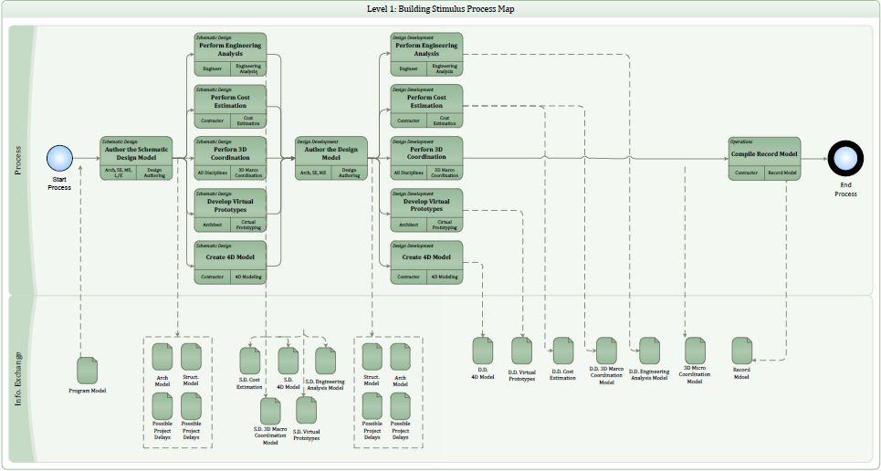

1. **List of Level Two – Detailed BIM Use Process Map(s):**
   1. Existing Conditions Modeling
   2. Phase Planning (4D Modeling)
   3. Programming
   4. Design Reviews
   5. Design Authoring
   6. Structural Analysis
   7. 3D Coordination
   8. 3D Control and Planning
   9. Record Modeling
   10. Building System Analysis

SECTION F: BIM INFORMATION EXCHANGE

**1. LIST OF INFORMATION EXCHANGE WORKSHEET**

* + Existing Conditions Modeling
  + Phase Planning (4D Modeling)
  + Programming
  + Design Reviews
  + Design Authoring
  + Structural Analysis
  + 3D Coordination
  + 3D Control and Planning
  + Record Modeling
  + Building System Analysis

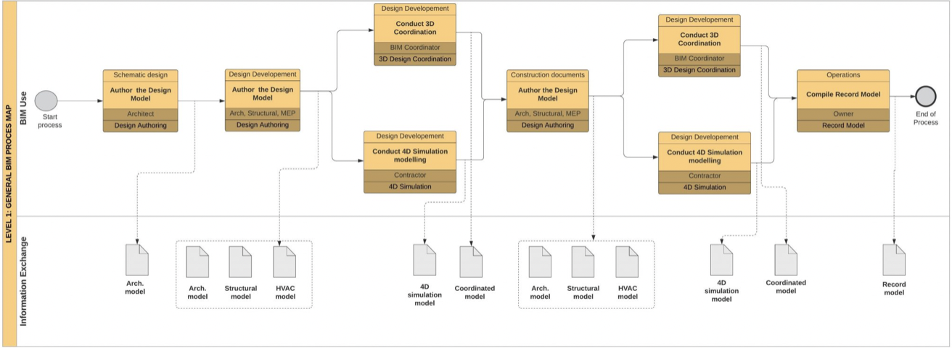

|  |
| --- |
| **SECTION G: MODEL STRUCTURE** |

**1. FILE NAMING STRUCTURE:**

|  |  |
| --- | --- |
| FILE NAMES FOR MODELS SHOULD BE FORMATTED AS: | |
| DISCIPLINE_PROJECTNUMBER_MODEL ZONE_FLOOR NAME_RELEATED PERSON_XYZ  EX: ARCH_2508_EX_L1_YSMN.rvt | |
| **ARCHITECTURAL MODEL** | ARCH |
| **MECHANICAL MODEL** | MECH |
| **STRUCTURAL MODEL** | STRUCT |

**Model Zone:**

EX: Exterior

IN: Interior

FC: Facade

**Floor Name:**

L0: Zemin Kat

L1: Birinci Kat

**Releated Person:**

Yasemen Şaldırak: YSMN

Kamer Özkan: KMR

Derya Çoban: DRY

Alper Güler: ALP

**2. NAMING FAMILIES:**

Example: YS_A_StructuralColumn_60X60

ReleatedPerson_Disiplin_Eleman_Özellik

YS,KÖ,DÇ,AG_ A,C_ CERAMIC_45X45

**3. NAMING VIEWS:**

|  |  |
| --- | --- |
| **Floor Plan Level-1** | First floor plan |
| **Ceiling Plan Level-1** | First ceiling plan |
| **AA** | Section-1 |
| **BB** | Section-2 |
| **South Elevation** | South Elevation |
|  |  |

**4. FOLDER STRUCTURE:**

**C:.**

**- tree.txt**

**-**

**+IZMIR EDUCATION CENTER PROJECT**

**+BIM**

**+01-WIP**

**- +BIM**

**- +CAD**

**- +Families**

**- +SheetFiles**

**+02-Shared**

**- +BIM**

**- +CAD**

**+03-Published**

**+04-Archived**

**+06-Resource**

**MODEL CONTENT:**

|  |  |  |
| --- | --- | --- |
| Wall BIM OBJECT OR ELEMENT | | |
|  | **Element Category-Wall** | |
| Description: 3D BIM Element. | |
| **Level Of Detail- Model Definition** | **Parameter Information** | **Parameter** |
| **LOD 300** | | |
| **A.**Accurate Size & Location,include materials and object parameters | **Physical Properties** | Length |
| **Physical Properties** | Area |
| **Physical Properties** | Volume |
| **Physical Properties** | Thickness |
| **Location Information** | Level Name |
| **Location Information** | Level ID |
| **Annotation Properties** | Type ID |
| **Material Information** | Material |
| **Quantification Properties** | WBS number |
| **Quantification Properties** | BOQ references No |
|  |  |  |
|  |  |  |
|  |  |  |
| **FAMILY TYPES** |  | |
| 1 | Drywall wall | |
| 2 | Aerated concrete wall | |
| 3 | Brick wall | |

|  |  |  |
| --- | --- | --- |
| Finished Wall BIM OBJECT OR ELEMENT | | |
|  | **Element Category-Wall** | |
| Description: 3D BIM Element. | |
| **Level Of Detail- Model Definition** | **Parameter Information** | **Parameter** |
| **LOD 300** | | |
| **A.**Accurate Size & Location,include materials and object parameters | **Physical Properties** | Length |
| **Physical Properties** | Area |
| **Physical Properties** | Volume |
| **Physical Properties** | Thickness |
| **Location Information** | Level Name |
| **Location Information** | Level ID |
| **Annotation Properties** | Type ID |
| **Material Information** | Material |
| **Quantification Properties** | WBS number |
| **Quantification Properties** | BOQ references No |
|  |  |  |
|  |  |  |
|  |  |  |
| **FAMILY TYPES** |  | |
| 1 | Ceramic | |
| 2 | Plaster cement,paint | |
| 3 | Granıte Ceramic | |

|  |  |  |
| --- | --- | --- |
| Floor BIM OBJECT OR ELEMENT | | |
|  | **Element Category- Flooring Systems** | |
| Description: 3D BIM Element. | |
| **Level Of Detail- Model Definition** | **Parameter Information** | **Parameter** |
| **LOD 300** | | |
| **A.** Accurate Size & Location,include materials and object parameters |  |  |
| **Physical Properties** | Area |
| **Physical Properties** | Volume |
| **Physical Properties** | Thickness |
| **Location Information** | Level Name |
| **Location Information** | Level ID |
| **Annotation Properties** | Type ID |
| **Material Information** | Material |
| **Quantification Properties** | WBS number |
| **Quantification Properties** | BOQ references No |
|  |  |  |
|  |  |  |
|  |  |  |
| **FAMILY TYPES** |  | |
| 1 | Reinforced concrete | |
| 2 |  | |
| 3 |  | |

|  |  |  |
| --- | --- | --- |
| Finished Floor BIM OBJECT OR ELEMENT | | |
|  | **Element Category-Flooring Systems** | |
| Description: 3D BIM Element. | |
| **Level Of Detail- Model Definition** | **Parameter Information** | **Parameter** |
| **LOD 300** | | |
| **A.** Accurate Size & Location,include materials and object parameters |  |  |
| **Physical Properties** | Area |
| **Physical Properties** | Volume |
| **Physical Properties** | Thickness |
| **Location Information** | Level Name |
| **Location Information** | Level ID |
| **Annotation Properties** | Type ID |
| **Material Information** | Material |
| **Quantification Properties** | WBS number |
| **Quantification Properties** | BOQ references No |
|  |  |  |
|  |  |  |
|  |  |  |
| **FAMILY TYPES** |  | |
| 1 | Ceramic_60x60 | |
| 2 | Granit | |
| 3 |  | |

|  |  |  |
| --- | --- | --- |
| Stair BIM OBJECT OR ELEMENT | | |
|  | **Element Category-Stair Systems** | |
| Description: 3D BIM Element. | |
| **Level Of Detail- Model Definition** | **Parameter Information** | **Parameter** |
| **LOD 200** | | |
| C. Schematic Size&Location | **Physical Properties** | Tread Depth |
| **Physical Properties** | Widht |
| **Physical Properties** | Number Of Risers |
| **Physical Properties** | Riser Height |
| **Location Information** | Base Level |
| **Location Information** | Top Level |
| **Annotation Properties** | Type ID |
| **Quantification Properties** | WBS number |
|  |  |  |
|  |  |  |
|  |  |  |
| **FAMILY TYPES** |  | |
| 1 |  | |
| 2 |  | |
| 3 |  | |

|  |  |  |
| --- | --- | --- |
| Column BIM OBJECT OR ELEMENT | | |
|  | **Element Category-Column** | |
| Description: 3D BIM Element. | |
| **Level Of Detail- Model Definition** | **Parameter Information** | **Parameter** |
| **LOD 200** | | |
| Accurate Size & Location,include materials and object parameters | **Physical Properties** | Length |
| **Physical Properties** | Widht |
| **Physical Properties** | Volume |
| **Physical Properties** | Area |
| **Location Information** | Level Name |
| **Location Information** | Level ID |
| **Annotation Properties** | Type ID |
| **Material Information** | Material |
| **Quantification Properties** | WBS number |
|  |  |  |
|  |  |  |
|  |  |  |
| **FAMILY TYPES** |  | |
| 1 | Concrete column | |
| 2 |  | |
| 3 |  | |

|  |  |  |
| --- | --- | --- |
| Beam BIM OBJECT OR ELEMENT | | |
|  | **Element Category-Column** | |
| Description: 3D BIM Element. | |
| **Level Of Detail- Model Definition** | **Parameter Information** | **Parameter** |
| **LOD 200** | | |
| Accurate Size & Location,include materials and object parameters | **Physical Properties** | Length |
| **Physical Properties** | Widht |
| **Physical Properties** | Volume |
| **Location Information** | Level Name |
| **Location Information** | Level ID |
| **Annotation Properties** | Type ID |
| **Material Information** | Material |
| **Quantification Properties** | WBS number |
|  |  |  |
|  |  |  |
|  |  |  |
| **FAMILY TYPES** |  | |
| 1 | Concrete beam | |
| 2 |  | |
| 3 |  | |

|  |  |  |
| --- | --- | --- |
| Structural Wall BIM OBJECT OR ELEMENT | | |
|  | **Element Category-Wall** | |
| Description: 3D BIM Element. | |
| **Level Of Detail- Model Definition** | **Parameter Information** | **Parameter** |
| **LOD 200** | | |
| **A.**Accurate Size & Location,include materials and object parameters | **Physical Properties** | Length |
| **Physical Properties** | Area |
| **Physical Properties** | Volume |
| **Physical Properties** | Thickness |
| **Location Information** | Level Name |
| **Location Information** | Level ID |
| **Annotation Properties** | Type ID |
| **Material Information** | Material |
| **Quantification Properties** | WBS number |
| **Quantification Properties** | BOQ references No |
|  |  |  |
|  |  |  |
|  |  |  |
| **FAMILY TYPES** |  | |
| 1 |  | |
| 2 |  | |
| 3 |  | |

|  |  |  |
| --- | --- | --- |
| CurtainWall BIM OBJECT OR ELEMENT | | |
|  | **Element Category-Facade Systems** | |
| Description: 3D BIM Element. | |
| **Level Of Detail- Model Definition** | **Parameter Information** | **Parameter** |
| **LOD 200** | | |
| **B.** General Size&Location, include parameter data | **Physical Properties** | Length |
| **Physical Properties** | Area |
| **Physical Properties** | Volume |
| **Physical Properties** | Width |
| **Location Information** | Level |
| **Annotation Properties** | Type ID |
|  |  |
|  |  |
|  |  |
|  |  |  |
|  |  |  |
|  |  |  |
| **FAMILY TYPES** |  | |
| 1 | Curtain Wall | |
| 2 |  | |
| 3 |  | |

|  |  |  |
| --- | --- | --- |
| Suspended Ceiling BIM OBJECT OR ELEMENT | | |
|  | **Element Category- Ceiling Systems** | |
| Description: 3D BIM Element. | |
| **Level Of Detail- Model Definition** | **Parameter Information** | **Parameter** |
| **LOD 200** | | |
| **B.** General Size&Location, include parameter data | **Physical Properties** | Perimeter |
| **Physical Properties** | Area |
| **Physical Properties** | Volume |
| **Physical Properties** | Thickness |
| **Location Information** | Height Offset From Level |
| **Location Information** | Level ID |
| **Annotation Properties** | Type ID |
| **Material Information** | Material |
| **Quantification Properties** | WBS number |
| **Quantification Properties** | BOQ references No |
|  |  |  |
|  |  |  |
|  |  |  |
|  |  |  |
| **FAMILY TYPES** |  | |
| 1 |  | |
| 2 |  | |
| 3 |  | |

|  |  |  |
| --- | --- | --- |
| Windows BIM OBJECT OR ELEMENT | | |
|  | **Element Category- Windows Systems** | |
| Description: 3D BIM Element. | |
| **Level Of Detail- Model Definition** | **Parameter Information** | **Parameter** |
| **LOD 300** | | |
| A.Accurate Size & Location,include materials and object parameters | **Physical Properties** | Height |
| **Physical Properties** | Widht |
| **Location Information** | Sill Height |
| **Location Information** | Level ID |
| **Annotation Properties** | Type ID |
| **Quantification Properties** | WBS number |
| **Quantification Properties** | BOQ references No |
|  |  |  |
|  |  |  |
|  |  |  |
| **FAMILY TYPES** |  | |
| 1 |  | |
| 2 |  | |
| 3 |  | |

|  |  |  |
| --- | --- | --- |
| Doors BIM OBJECT OR ELEMENT | | |
|  | **Element Category- Doors Systems** | |
| Description: 3D BIM Element. | |
| **Level Of Detail- Model Definition** | **Parameter Information** | **Parameter** |
| **LOD 300** | | |
| **A.**Accurate Size & Location,include materials and object parameters | **Physical Properties** | Height |
| **Physical Properties** | Widht |
| **Physical Properties** | Thickness |
| **Location Information** | Level ID |
| **Annotation Properties** | Type ID |
| **Quantification Properties** | WBS number |
| **Quantification Properties** | BOQ references No |
|  | **Material Information** | Material |
|  |  |  |
|  |  |  |
| **FAMILY TYPES** |  | |
| 1 |  | |
| 2 |  | |
| 3 |  | |

|  |
| --- |
| **SECTION H: COMMON DATA ENVIRONMENT** |

**tablo içeren bir resim

Açıklama otomatik olarak oluşturuldu**

|  |
| --- |
| **SECTION I: DATA SEGREGATION / FEDERATION** |

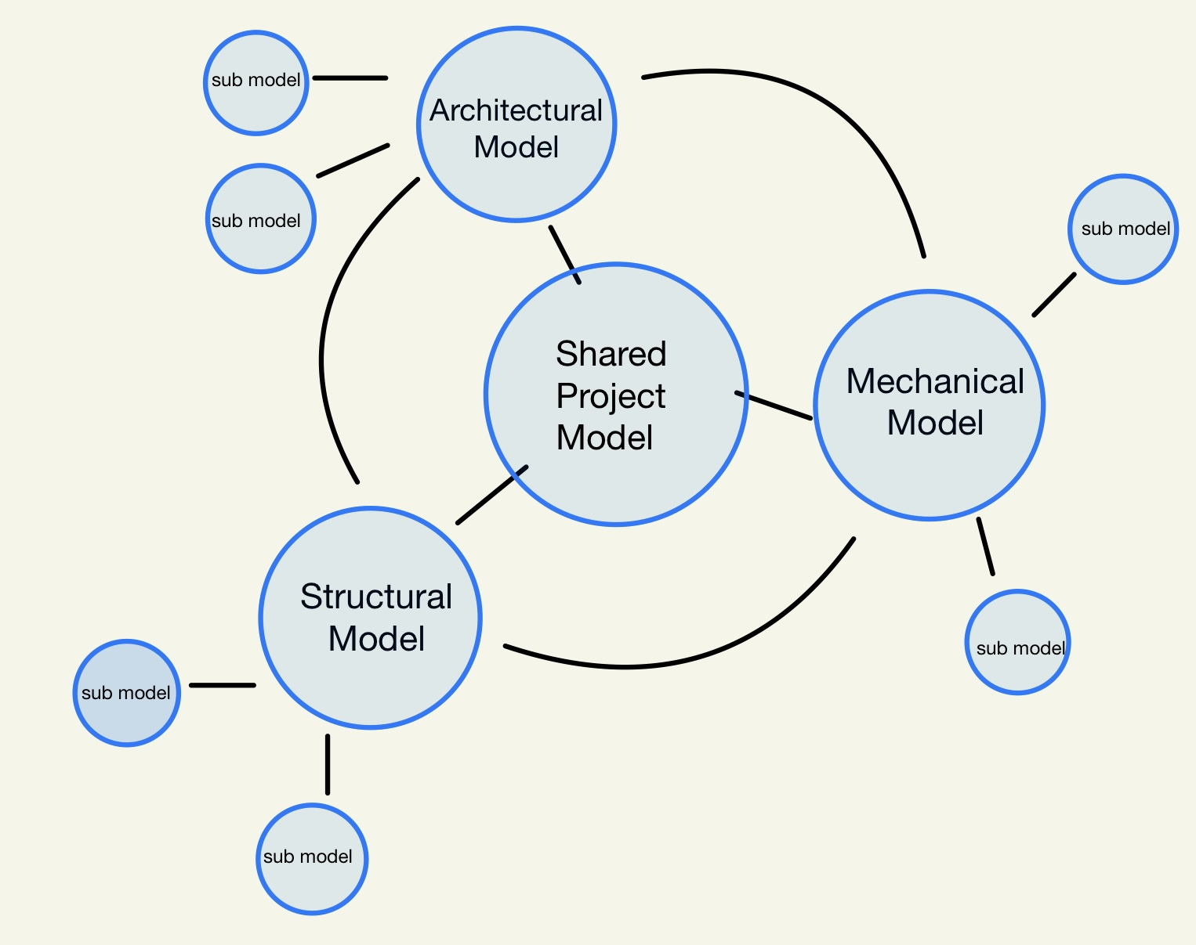

SECTION J: COLABORATION PROCEDURES

1. **Collaboration Strategy:**

Describe how the project team will collaborate. Include items such as communication methods, document management and transfer, and record storage, etc.

Meeting schedule to be followed strictly to determine&update progress, to point out problems and to create solution mechanisms. Meetings that cannot be held will be rescheduled through Zoom Program .

Acoustic, Catering, Facility Management, Fire consultants will attend pre design meetings.

Minutes of Meetings will be shared to all participants and related departments through email.

Each department should update their data/model/document through Document Controller, DCC department will notify concerned departments on each update and will share weekly LOG.

1. **Meeting Procedures:**

The following are examples of meetings that should be considered.

|  |  |  |  |  |
| --- | --- | --- | --- | --- |
| **MEETING TYPE** | **PROJECT STAGE** | **FREQUENCY** | **PARTICIPANTS** | **LOCATION** |
| KICK OFF | PRE | Once | Entire Project Teams | Conference Call |
| BIM EXECUTION PLAN DEMONSTRATION | BIM Process Model | Once | Entire Project Teams | Conference Call |
| DESIGN COORDINATION | Design Development | Weekly | Entire Project Teams | Conference Call |

1. **Model Delivery Schedule of Information Exchange for Submission and Approval:**

Document the information exchanges and file transfers that will occur on the project.

|  |  |  |  |  |  |  |  |  |
| --- | --- | --- | --- | --- | --- | --- | --- | --- |
| **INFORMATION EXCHANGE** | **FILE**  **SENDER** | **FILE**  **RECEIVER** | **ONE-TIME or FREQUENCY** | **DUE DATE or START DATE** | **MODEL FILE** | **MODEL SOFTWARE** | **NATIVE FILE TYPE** | **FILE EXCHANGE TYPE** |
| DESIGN AUTHORING - 3D COORDINATION | STRUCTURAL ENGINEER | BIM Manager | WEEKLY | 15 NOV 2022 | STRUCT | REVIT | .RVT | .RVT  .NWD |
| DESIGN AUTHORING - 3D COORDINATION | ARCHITECTURAL DESIGNER | BIM Manager | WEEKLY | 15 NOV 2022 | ARCH | REVIT | .RVT | .RVT  .NWD |
|  |  |  |  |  |  |  |  |  |

1. **Electronic Communication Procedures:**

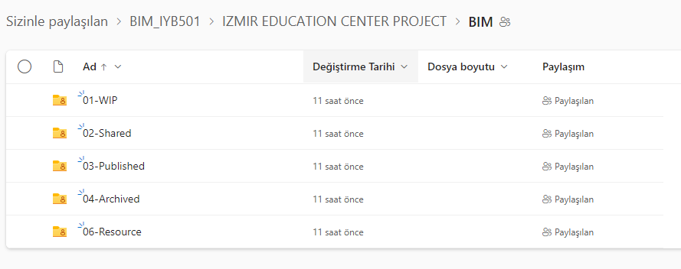

SECTION K: QUALITY CONTROL

1. **OVERALL STRATEGY FOR QUALITY CONTROL:**

All disciplines will use a common base point to ensure that computer models will align when imported for collaboration in Revit and NavisWorks. Individual models will be checked continuously to ensure the design intent, model codes, and correct standards are followed. Issues that arise interdisciplinary will be addressed in group meetings and resolved accordingly, whereas intradisciplinary problems will be solved on an individual basis.

1. **QUALITY CONTROL CHECKS:**

The following checks should be performed to assure quality

|  |  |  |  |  |
| --- | --- | --- | --- | --- |
| **CHECKS** | **DEFINITION** | **RESPONSIBLE PARTY** | **SOFTWARE PROGRAM(S)** | **FREQUENCY** |
| VISUAL CHECK | Ensure there are no unintended model components and the design intent has been followed | All Project Managers | Revit | Continuously |
| INTERFERENCE CHECK | Detect problems in the model where two building components are clashing including soft and hard | BIM Manager | Navisworks | Weekly |
| STANDARDS CHECK | Ensure that the BIM and AEC CADD Standard have been followed (fonts, dimensions, line styles, levels/layers, etc) | All Project Managers | Revit | Continuously |
| MODEL INTEGRITY CHECKS | Describe the QC validation process used to ensure that the Project Facility Data set has no undefined, incorrectly defined or duplicated elements and the reporting process on non-compliant elements and corrective action plans | All Project Managers | Revit | Continuously |

1. **Model Accuracy and Tolerances:**

Models should include all appropriate dimensioning as needed for design intent, analysis, and construction. Level of detail and included model elements are provided in the Information Exchange Worksheet

|  |  |  |
| --- | --- | --- |
| **PHASE** | **DISCIPLINE** | **TOLERANCE** |
| DESIGN DOCUMENTS | ALL | ACCURATE TO +/- 1” OF ACTUAL SIZE AND LOCATION |
|  |  |  |

SECTION L: TECHNICAL INFRASTRUCTURE REQUIREMENT

1. **Software:**

Different software will be used in order to achieve the BIM usage targets determined within the scope of the project. The main software and version information to be used in the design process are listed in the table below.

|  |  |  |  |
| --- | --- | --- | --- |
| **BIM USE** | **DISCIPLINE**  **(if applicable)** | **SOFTWARE** | **VERSION** |
| DESIGN AUTHORING | Architect | REVIT | Revit Arch. 2022 |
| STRUCTURAL ANALYSIS | Structural Engineer | Revit, MS Excel | Revit Structure 2022, MS Excel 2022 |
| 3D Coordination (Design) | All Disciplines | Revit, Navisworks | Revit Suite 2022, Navisworks Manage 2022 |

1. **Computers / Hardware:**

Understand hardware specification becomes valuable once information begins to be shared between several disciplines or organizations. It also becomes valuable to ensure that the downstream hardware is not less powerful than the hardware used to create the information. In order to ensure that this does not happen, choose the hardware that is in the highest demand and most appropriate for the majority of BIM Uses.

Throughout the project, equipment will be used to ensure that all BIM usage processes proceed smoothly.

|  |  |  |  |
| --- | --- | --- | --- |
| **BIM USE** | **HARDWARE** | **OWNER OF HARDWARE** | **SPECIFICATIONS** |
| DESIGN AUTHORING  STRUCTURAL ANALYSIS  3D Coordination (Design) | COMPUTER SYSTEM | All Disciplines | **PROCESSOR INTERL CORE 7, OPERATING SYSTEM WINDOWS7,**  **MEMORY STORAGE 1 TB, GRAPHICS NVIDIA GeForce 1GB,** |
|  |  |  |  |
|  |  |  |  |

1. **Modeling Content and Reference Information**

Identify items such as families, workspaces, and databases.

|  |  |  |  |
| --- | --- | --- | --- |
| **BIM USE** | **DISCIPLINE**  **(if applicable)** | **MODELING CONTENT /**  **REFERENCE INFORMATION** | **VERSION** |
| DESIGN AUTHORING | Architect | Revit families, floor plans, sections, details, etc. | Revit Architecture 2022 |
| Existing Conditions Modeling | Construction Manager | All existing design conditions | Revit Architecture 2022 |
| Structural Analysis | Structural Engineer | Structural design loads and structural system | Revit Structure 2022, MS Excel 2022 |
| 4D Modeling | Construction Manager | Merging of the disciplines models with construction phases and schedules | Navisworks Manage 2022, |
| Cost Estimation | Construction Manager | Use of other trades models to create a detail cost estimation | Quantity Takeoff 2022, Revit 2022 |
| 3D Coordination (Design) | All Disciplines | Use of all trades models to create a 3D environment to ensure a clash free design | Revit 2022, Navisworks 2022 |
| Design Reviews | All Disciplines | Review designs to ensure efficiency and constructability | Revit Architecture 2022 |
|  |  |  |  |
|  |  |  |  |

SECTION M: PROJECT DELIVERABLES

In this section, list the BIM deliverables for the project and the format in which the information will be delivered.

|  |  |  |  |  |
| --- | --- | --- | --- | --- |
| **BIM SUBMITTAL ITEM** | **STAGE** | **Approximate Due Date** | **FORMAT** | **NOTES** |
| RVA Architecture Model | Existing Conditions | Nov 15 ,2022 | .RVT |  |
| Structural Design Model | Existing Conditions Modeling | Nov 15 ,2022 | .RVT |  |
| Navisworks Model | Design Coordination | Continuously | .RVT & .NWD |  |
| Schematic Design Arch Model | Design Authoring | Nov 17 ,2022 | .RVT |  |
| Schematic Design Structural Model | Design Authoring | Nov 19 ,2022 | .RVT |  |
| Schematic Cost Estimate | Cost Estimation | Nov 19 ,2022 | RVT & .QTO |  |
| Schematic Schedule | 4D Modeling | Nov 21 ,2022 | .XER .XLSX |  |
| Development Arch Model | Design Authoring | Dec 1 ,2022 | .RVT |  |
| Development Structural Model | Structural Analysis | Dec 2 ,2022 | .SDB & .RVT |  |
| Development Cost Estimate | Cost Estimation | Dec 2 ,2022 | .RVT & .QTO |  |
| Development Schedule | 4D Modeling | Dec 4 ,2022 | XER .XLSX |  |
| 4D Model | 4D Modeling | Dec 5 ,2022 | .NWD & .RVT |  |
|  |  |  |  |  |

SECTION N: DELIVERY STRATEGY / CONTRACT

1. **Delivery and Contracting Strategy for the project:**

When attempting to implement an extensive BIM plan in a traditional design-bid-build project, it is vital to examine the scopes and cost estimates of a potential sub-contractor, as well as their commitment and competency regarding Building Information Modeling.

A sub-contractors ability to fulfill their contractual BIM obligations relies heavily on their belief into BIM’s ability to streamline a project and assist in resolving potential conflicts as early as possible. During the sub-contractor selection process, it is important previous examples of projects where BIM was used, and how it contributed to a projects successful completion.

When developing contracts to present to sub-contractor candidates, the desire to utilize BIM substantially should be incorporated. Specifically, sub-contractors need to be aware of exact instances and examples of models which will be required. A specific set of guidelines shall be provided to inform candidates of the extent to which BIM models need to be created, updated, and shared. Examples of these guidelines include frequency of design review meetings where sub-contractor models will be shared and combined, the specific software and file format to be followed to avoid compatibility issues, and also methods to creating a model such as layer creation, name designation, and even colors designated to specific trades.

When receiving bids from sub-contractor candidates, the lowest cost may seem most desirable, however, it is necessary to weigh the costs of a team experienced and committed in the implementation of BIM versus a team whose technological growing pains could result in unexpected delays.

1. **Team SelectIon Procedure:**

Team selection procedure has already been completed and teams have been finalized.

1. **BIM ContractIng Procedure:**

Contracts should include required guidelines and expectancies regarding BIM from candidates. Proof of experience in the implementation of BIM is preferred but not necessary. Failure to achieve contractual obligations could result in withholding of retainage and payments to sub-contractor.